What is the total value of the coins below?
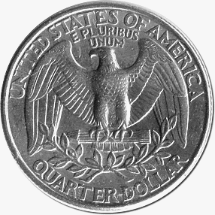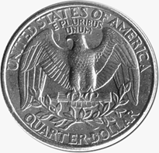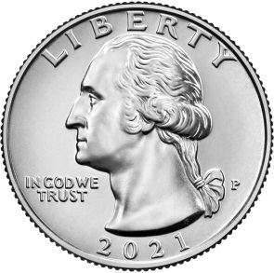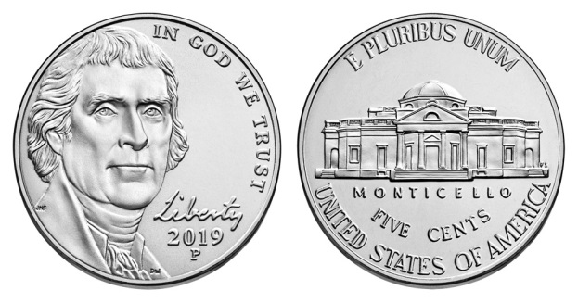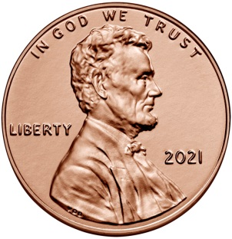
To obtain the value of the coins above, one has to identify the value of each coin then summate them to obtain the final answer.
Step 1: Identifying the coins and their values
Cent Name Picture Value
Quarter (Back side) 25¢
Quarter (Front side) 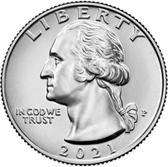 25¢
Nickel (Front and back side) 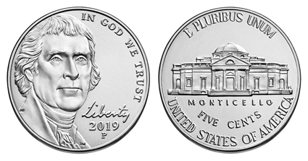 5¢ each
Penny 1 cent

Step 2: Addition of all the coins
25 cents + 25 cents + 5 cents x 2 = 10 cents
+ 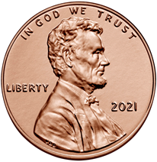 1 penny
Step 3: (25 + 25 + 5 + 5 + 1) cents = 86 cents (Final answer)

